**Perform Search and adaptation for Key Mapping Based on Business Partner**

*Creating a business partner*

i) Open transaction BP

ii) Choose organisation 🡪 Create organisation

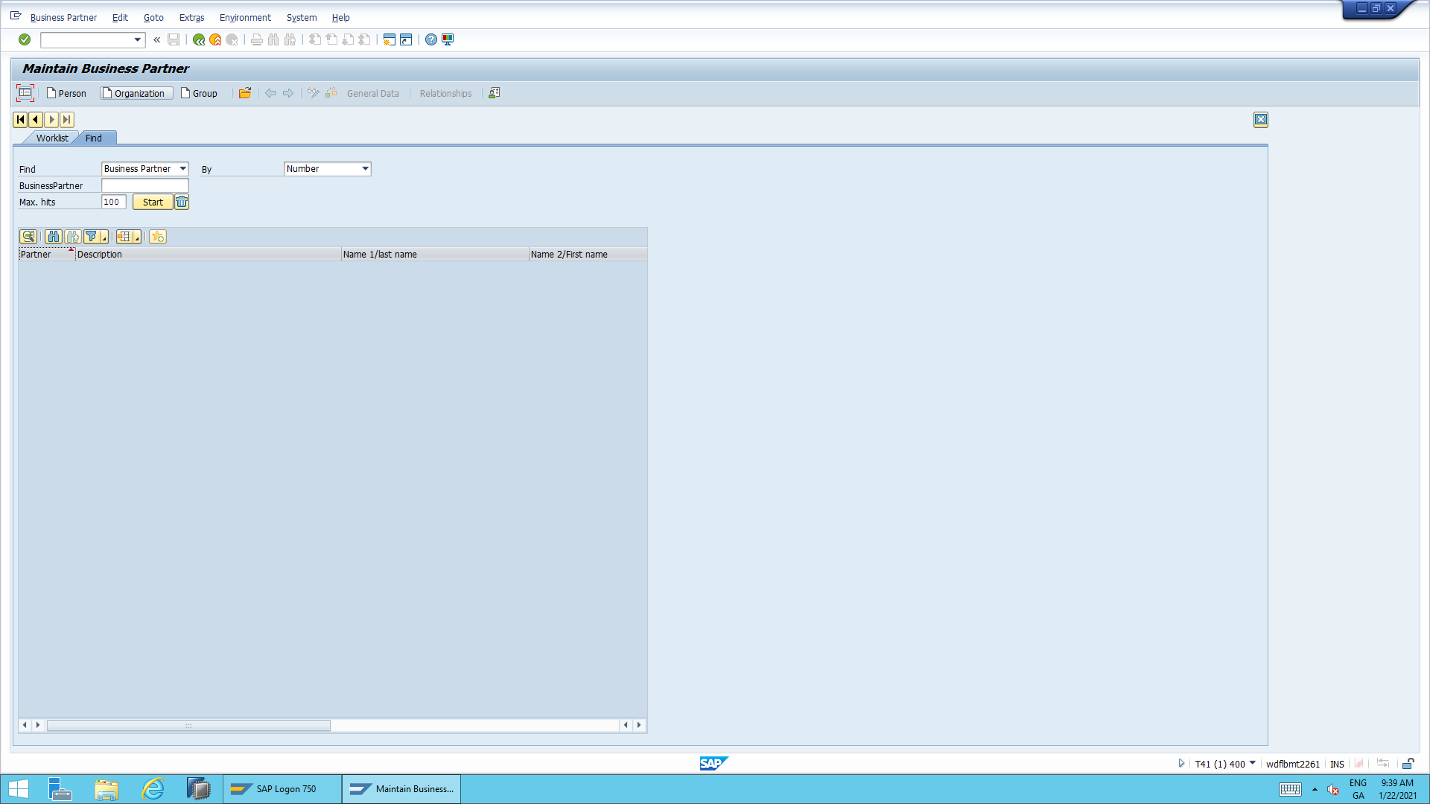

iii) Fill in the details as follows:

*Grouping: ‘ Ext.alpha-num.numb.(a-z;CUST/SUPL)’*

*Business Partner; MDG200_02*

*Name : Replication Group*

*Serach term: REPL01*

*Address: As below*

*Language: English*

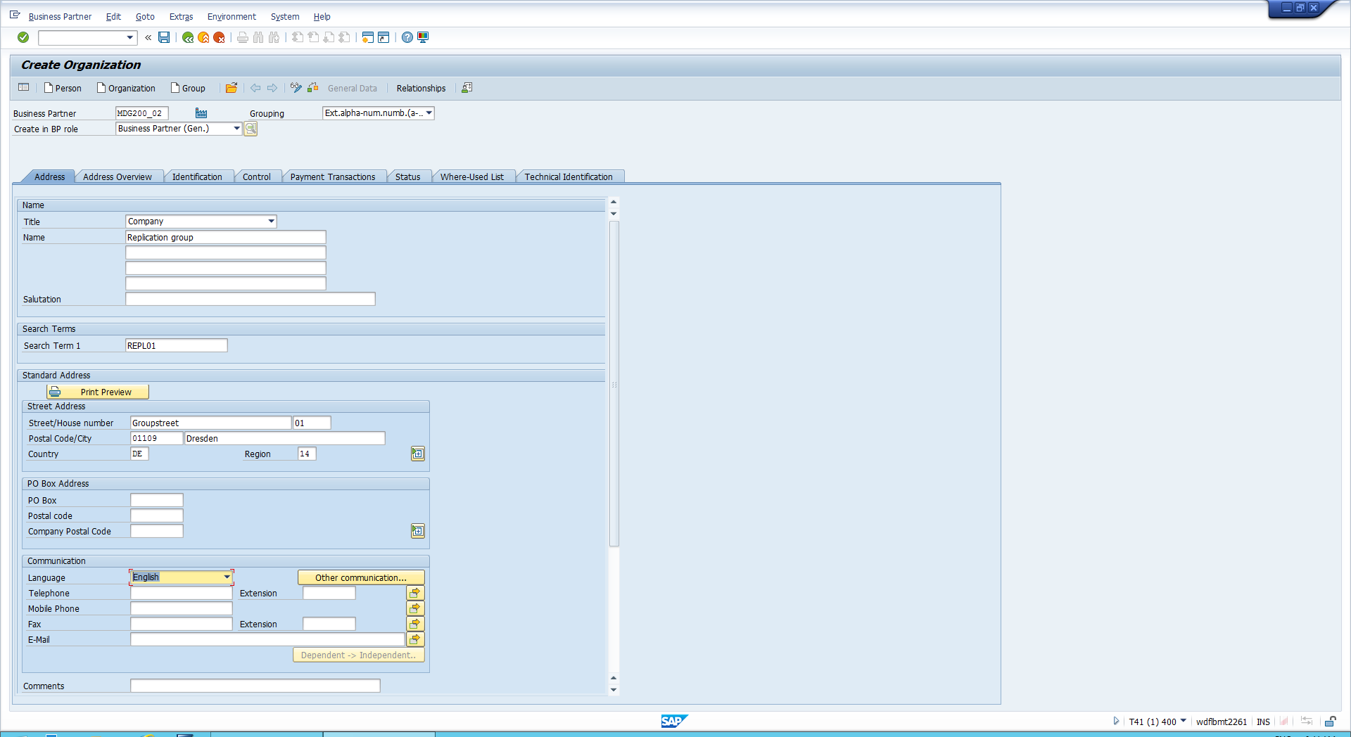

iv) Choose save 🡪 Click switch between display and change (glasses & pen icon)

v) Change the BP role from Business Partner (Gen.) to Supplier

vi) Choose purchasing 🡪 input Purchasing organisation as 1010 🡪 order currency as EUR 🡪 Save and exit

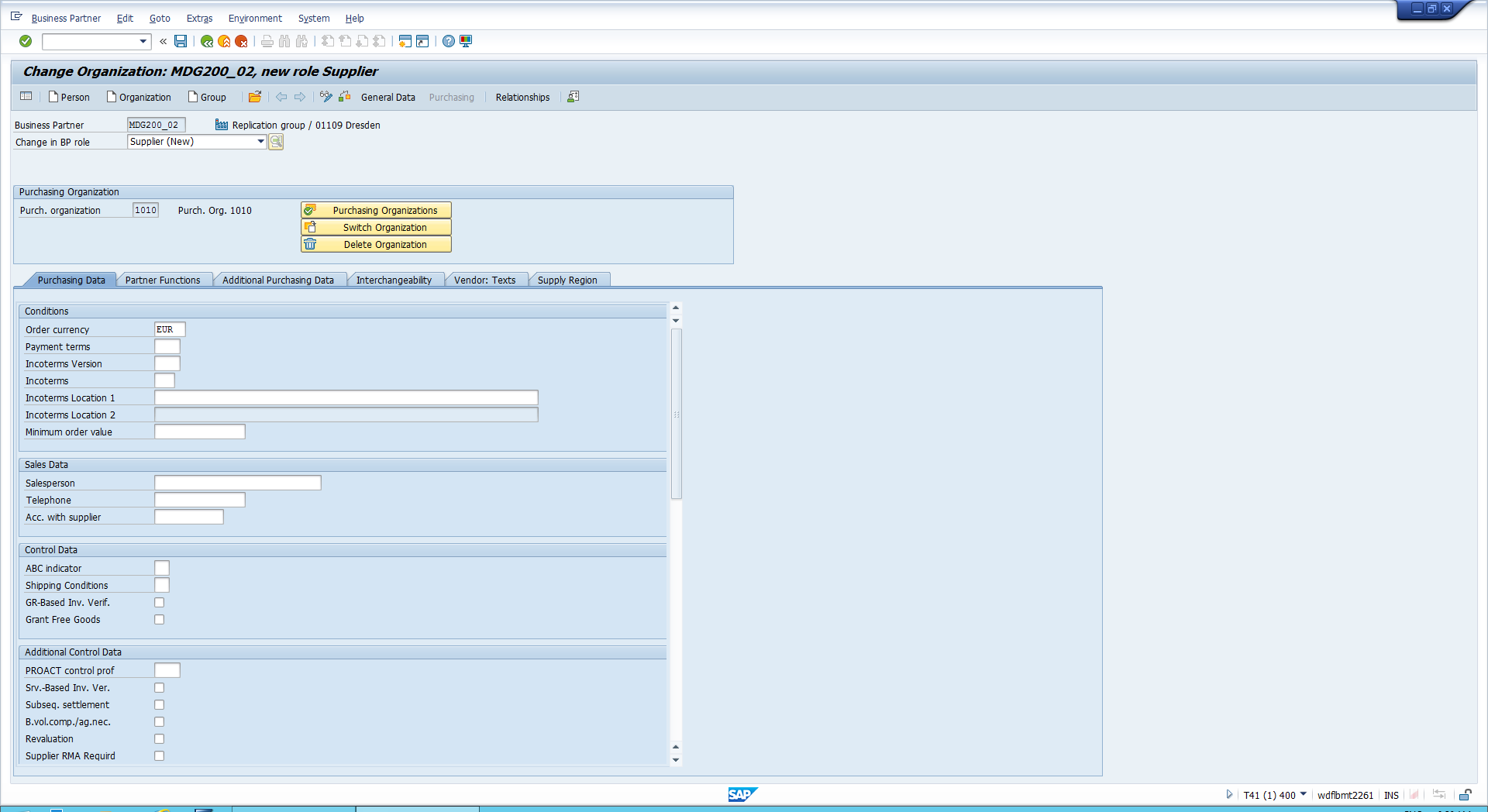

In the following steps, you will navigate to the business partner tile and perform replication for the created business partner from T41/400 to t41/T401 system

*Replicating the Business Partner*

i) Open NWBC🡪 Navigate to Business partner Governance 🡪choose ‘Replicate by Business partner Selection’

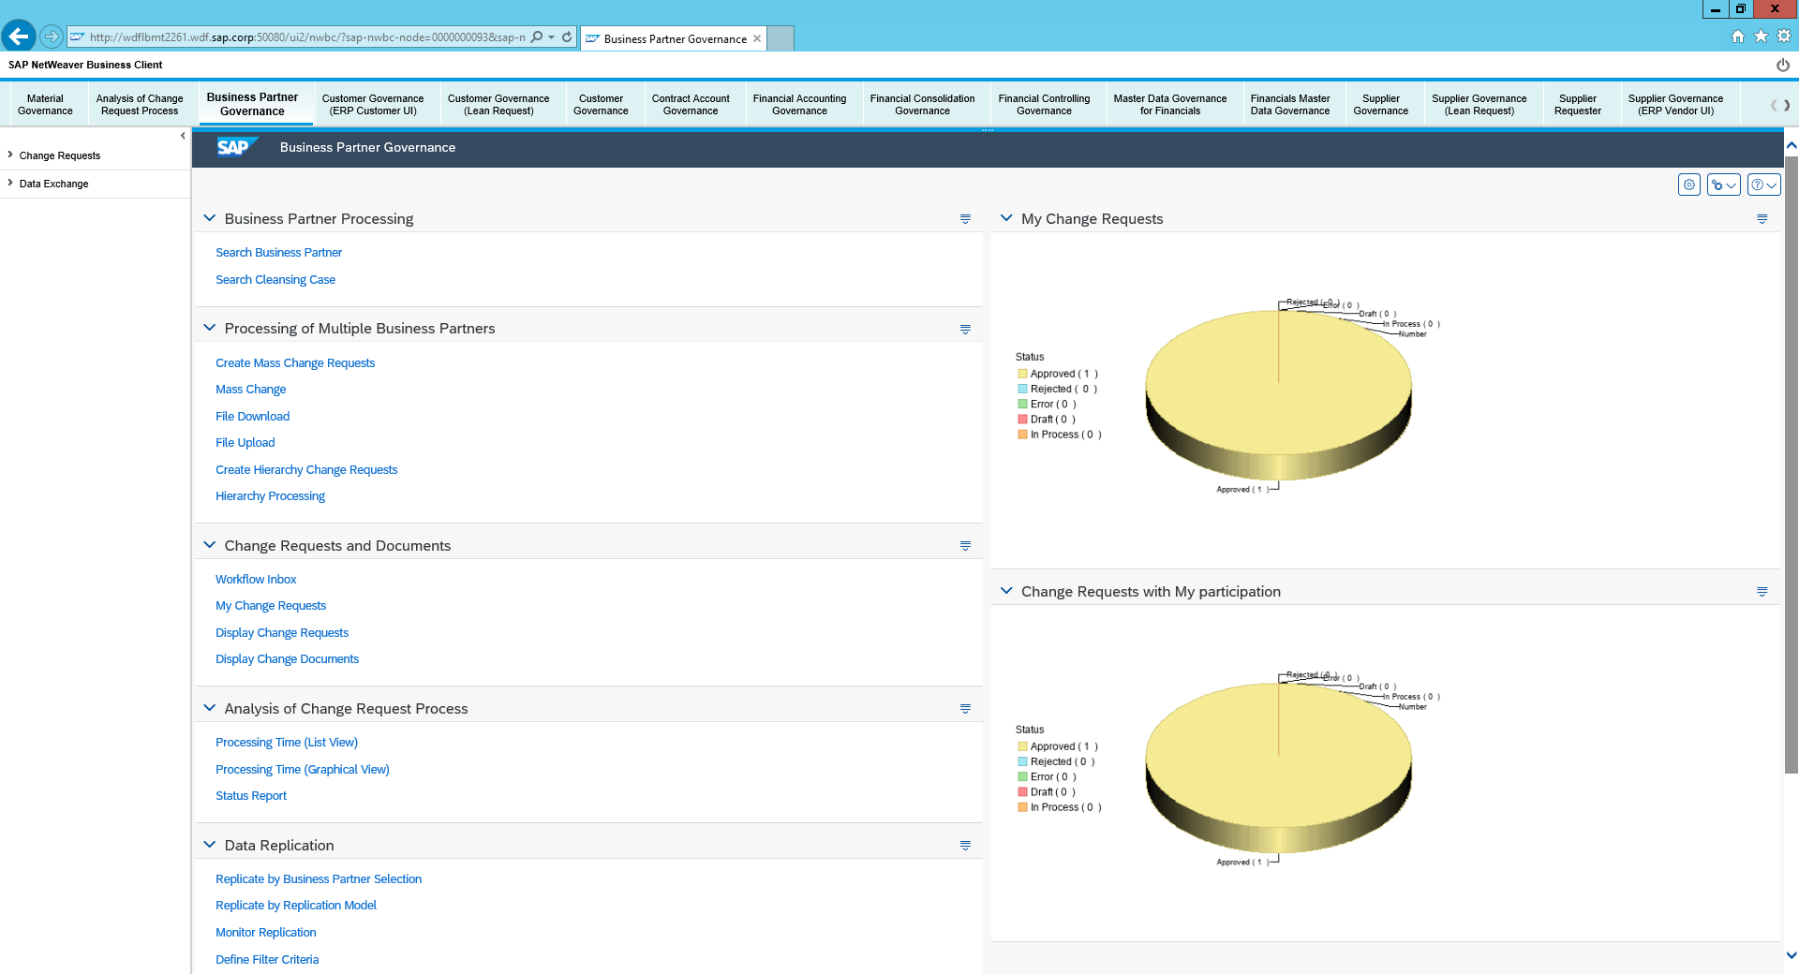

ii) Ensure Business object type is set to ‘Business Partner Including Relationships’ 🡪 Input your partner ID as below eg: MDG200_02 🡪 Select the partner and then select Your client on the right side of the screen 🡪 Click replicate in the right bottom corner

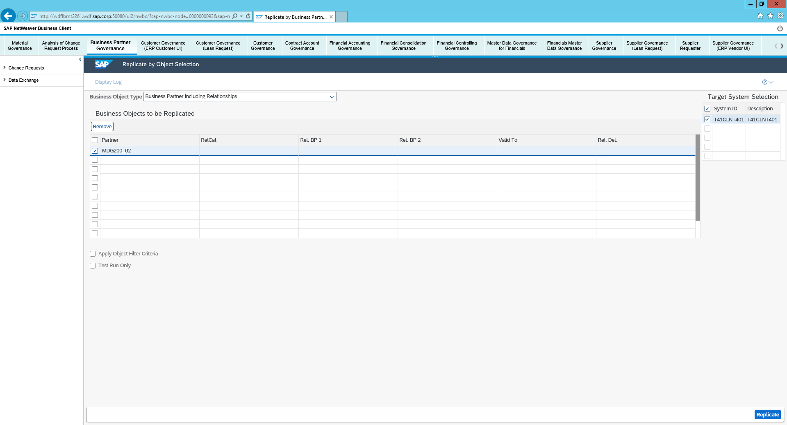

iii) Once replicated you can now click on display logs in the top left corner 🡪 This will bring up the replication log for the Replication

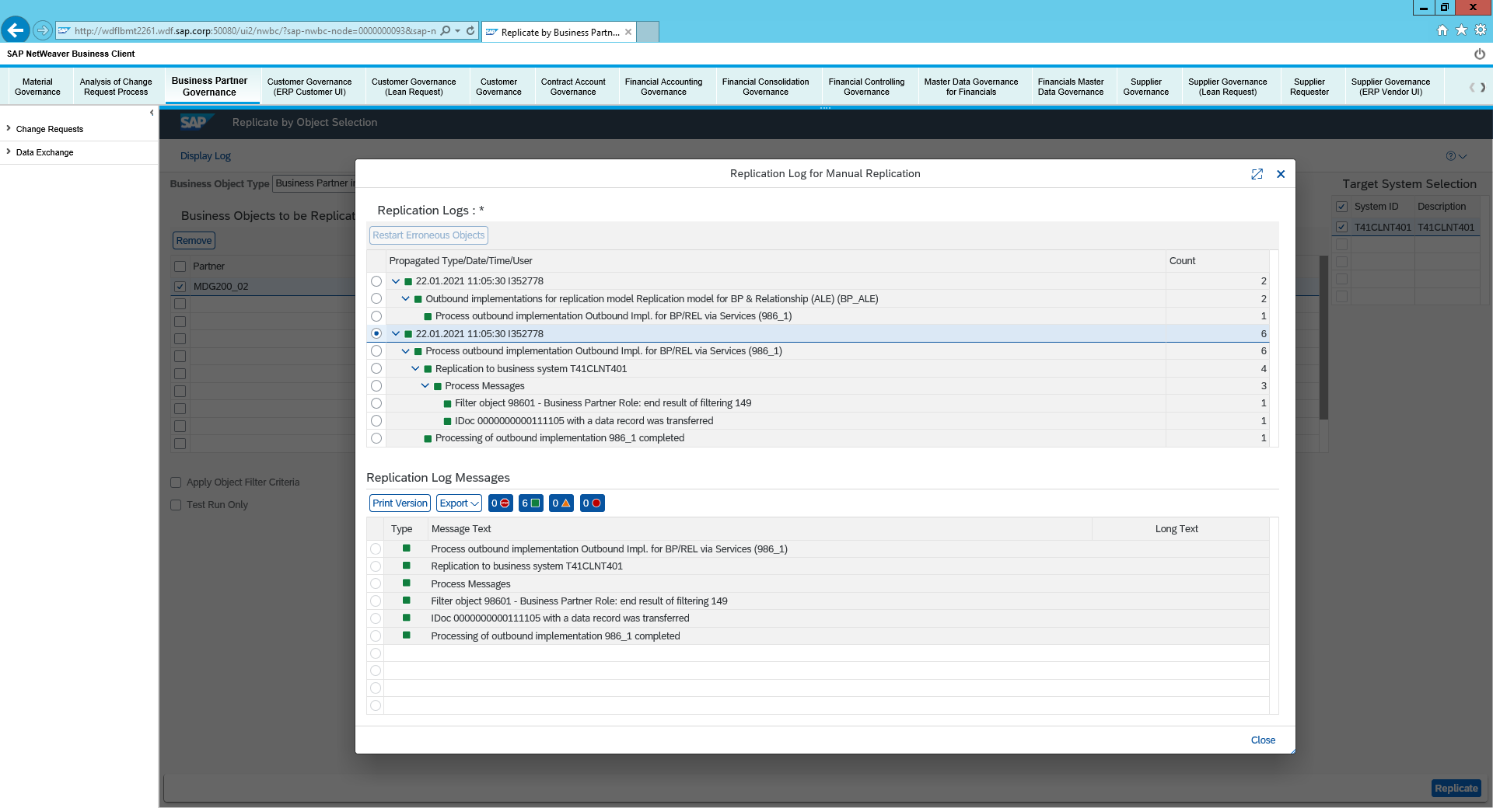

iv)Return to Easy Access Menu 🡪 Enter WE02 transaction 🡪 Click execute

v)Find your IDOC number & msg type should be BUPA as below:

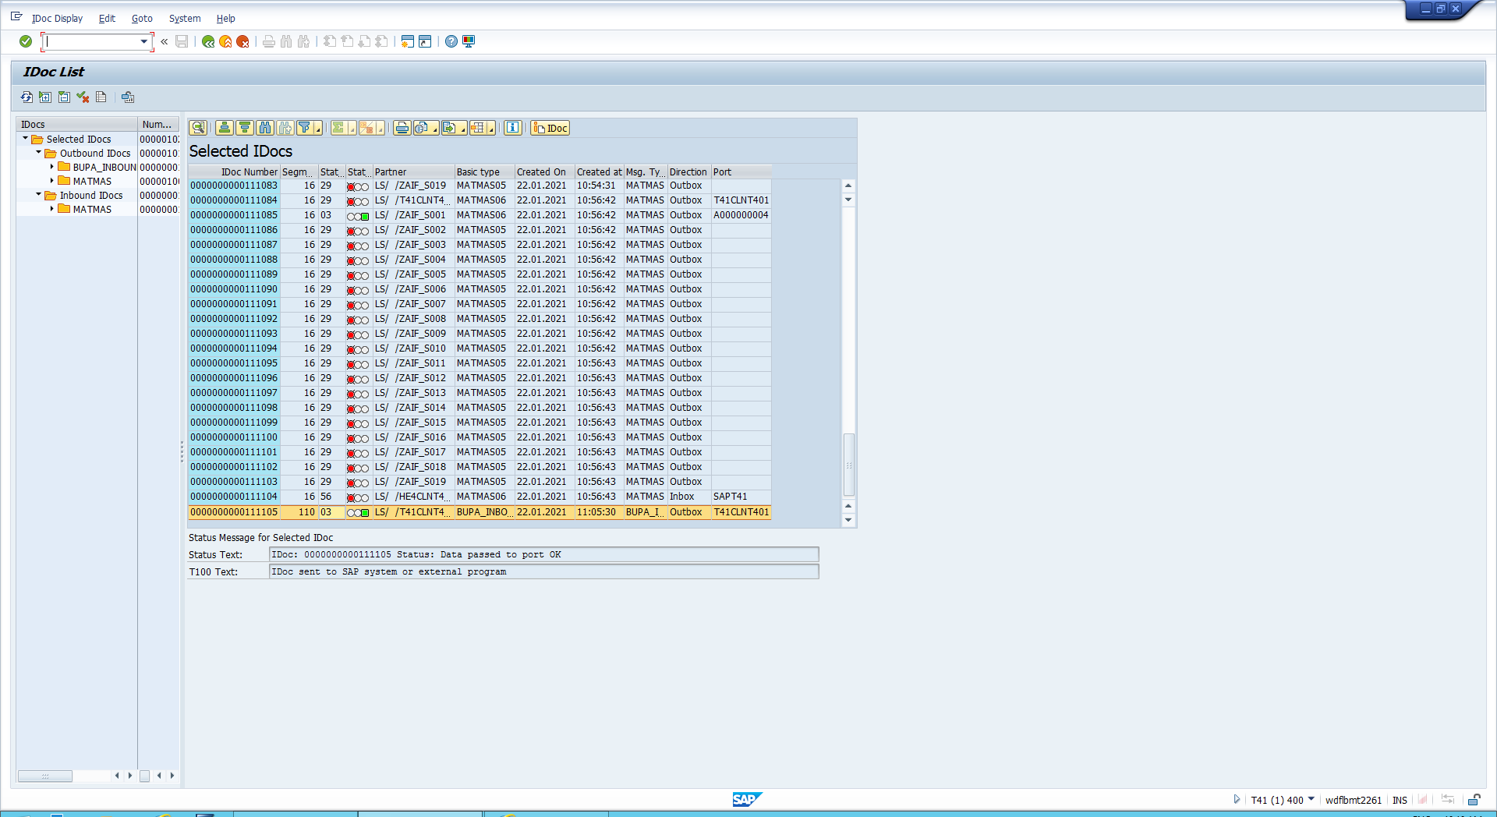

vii) Double click on it 🡪 Open data records 🡪 navigate to segement 3 🡪 double click on it and see the status of your replication

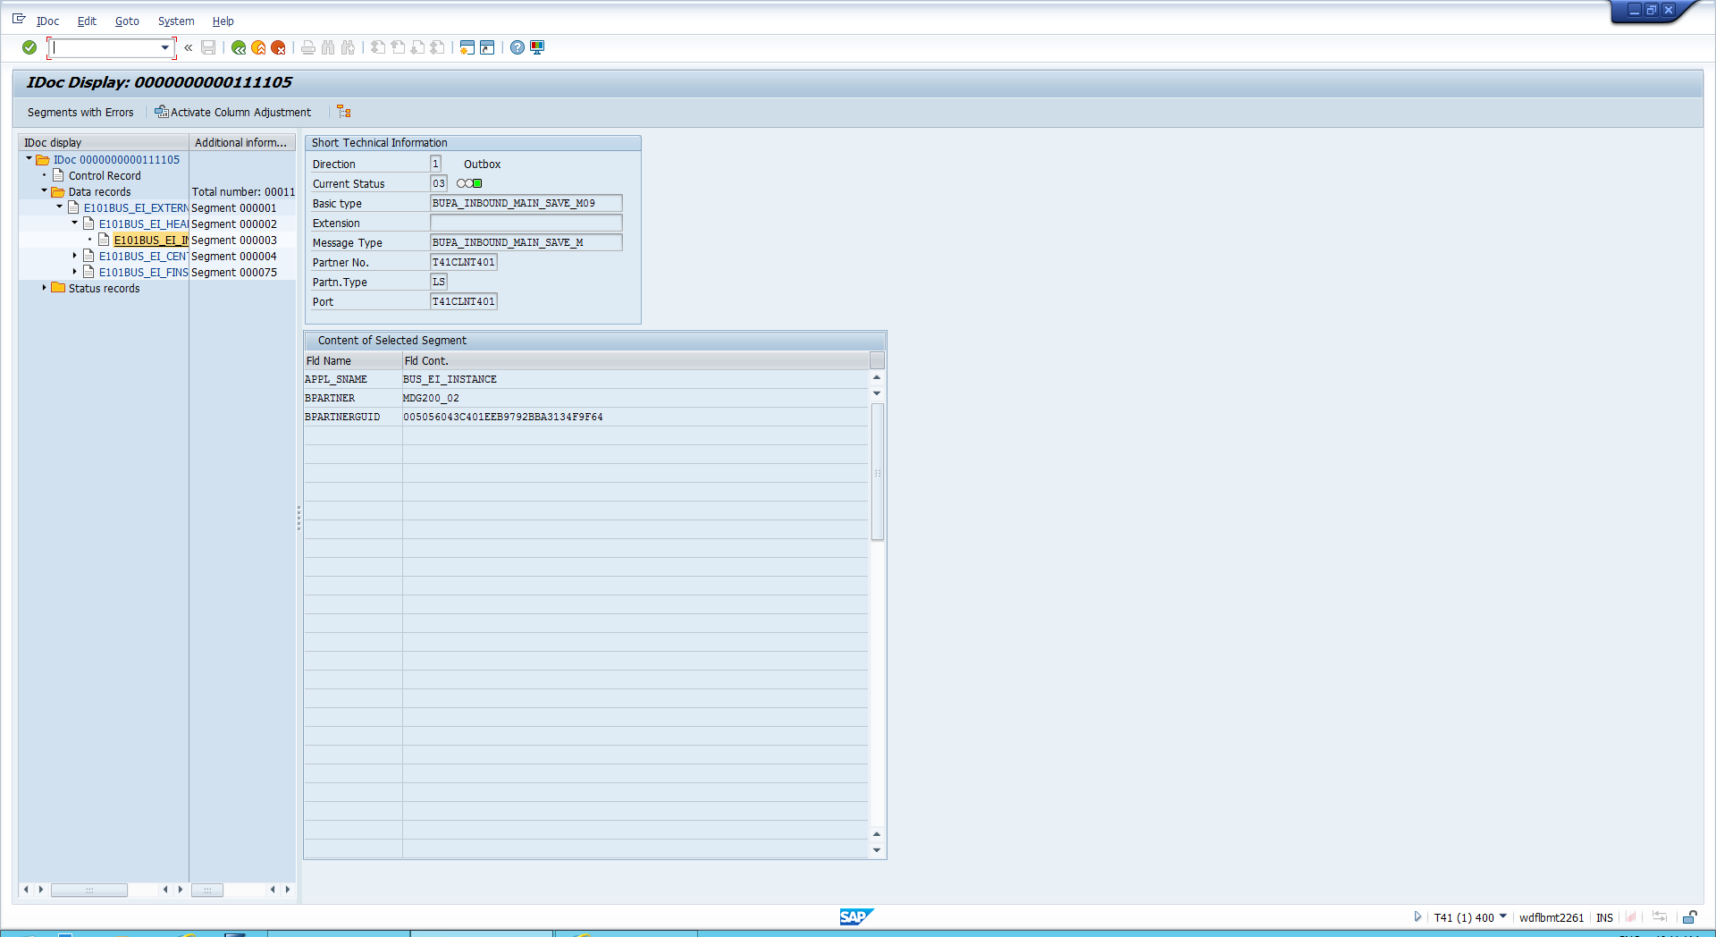

Check the status

i) Return to Easy Access menu 🡪 Enter BD87 transaction code

ii) Input your idoc number and click execute

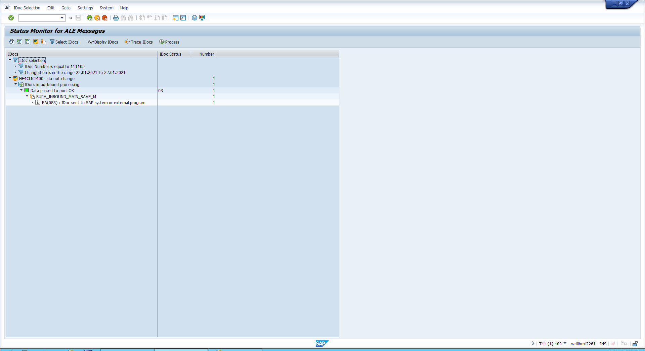

iii) Click through to view your ALE Status messages

Checking Your business partner on both systems

i) Open transaction BP🡪 Search your business Partner 🡪 select tab ‘Vendor general Data’ 🡪 You can now see the vendor number assigned in T40 Client under ‘Vendor number’

ii) Exit this and enter transaction SM59 🡪 Open ABAP connections and locate T41CLNT401 🡪 Double click this

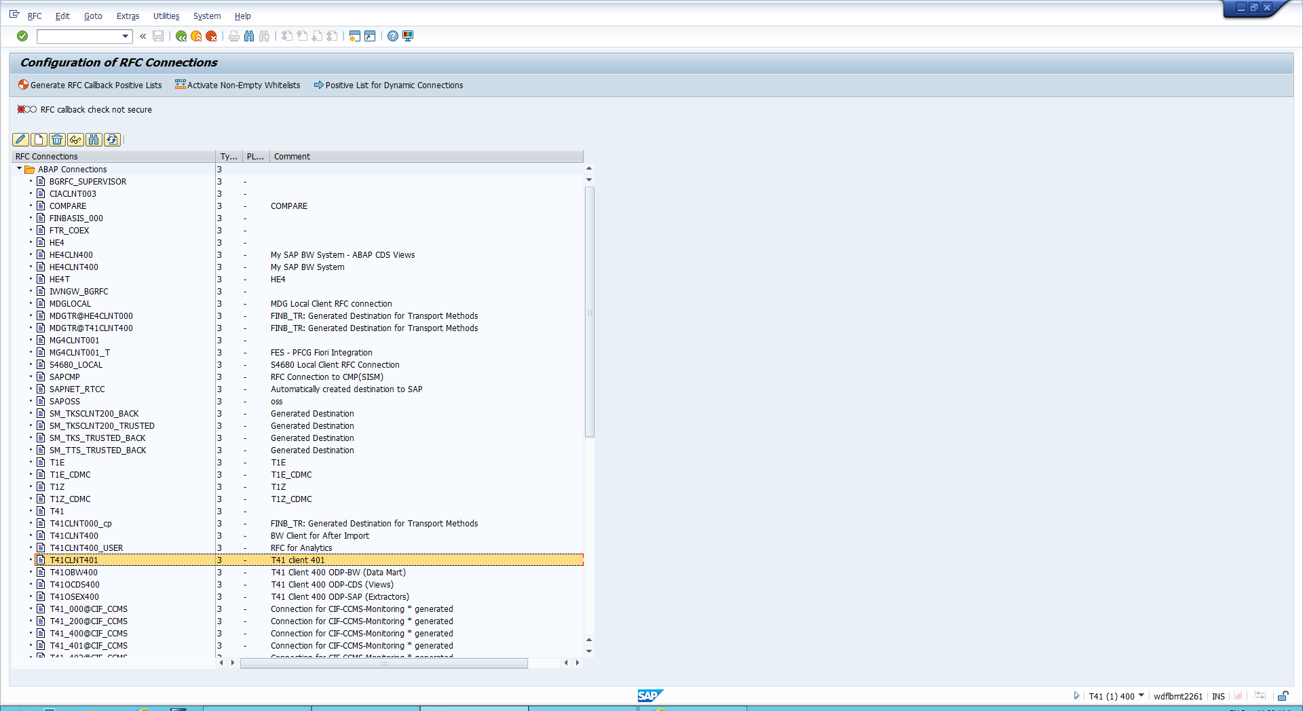

iii)In the new screen click remote Logon

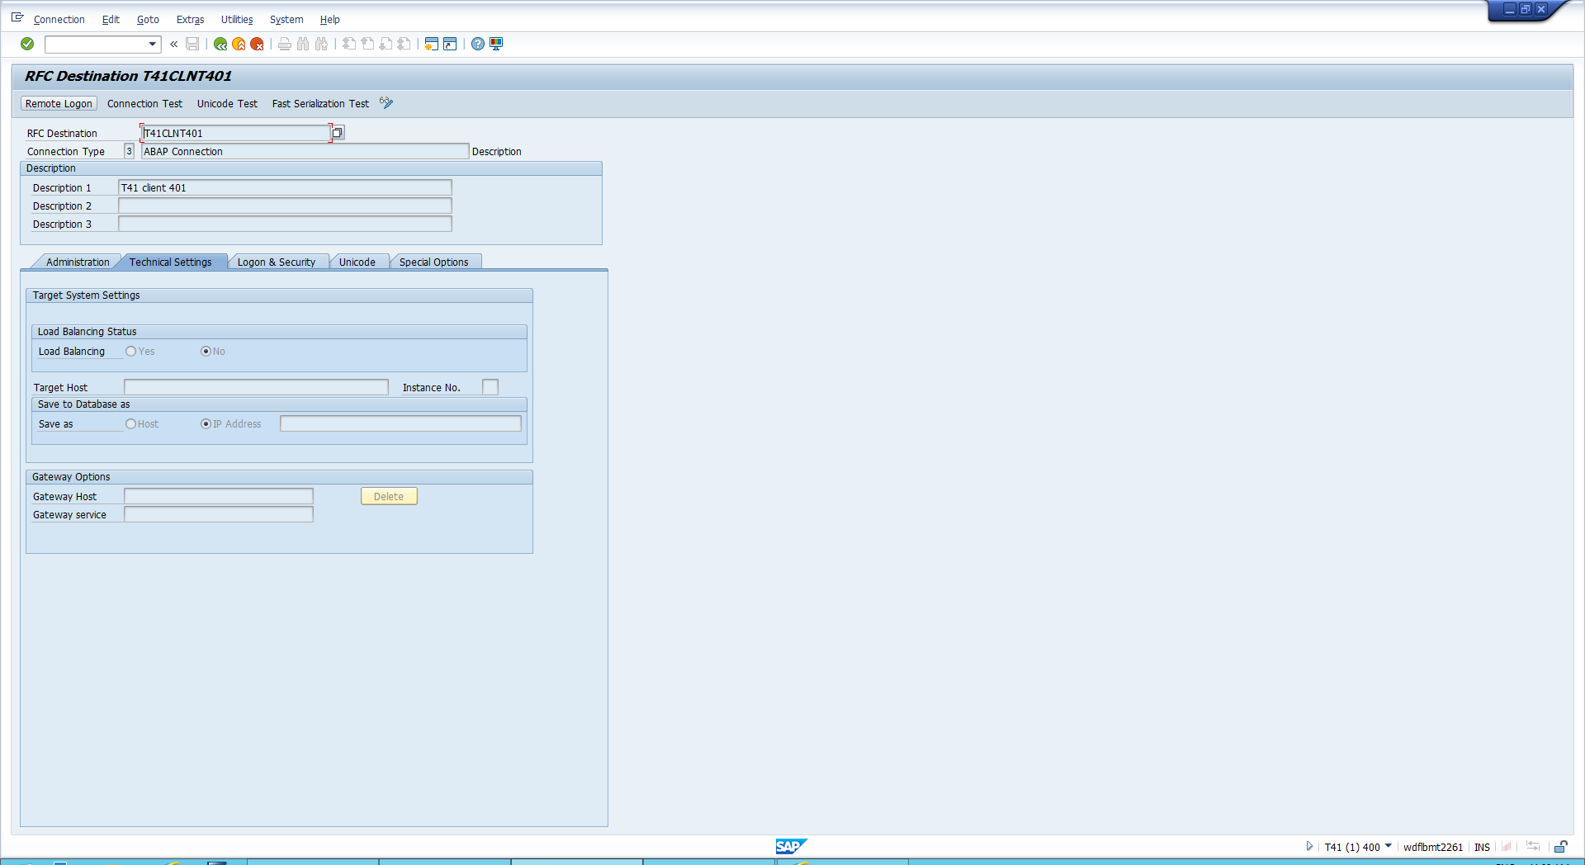

You are now logged into the 401 system this is where you replicated your business partner to

iv) Return to Easy access in this system -> enter BP transaction and search your Business partner

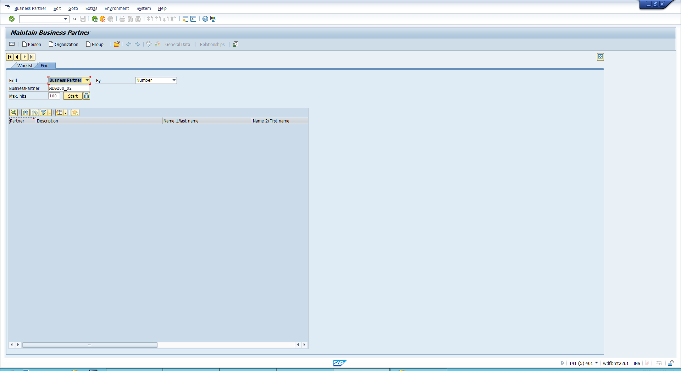

v) Enter your business partner and change the role to supplier

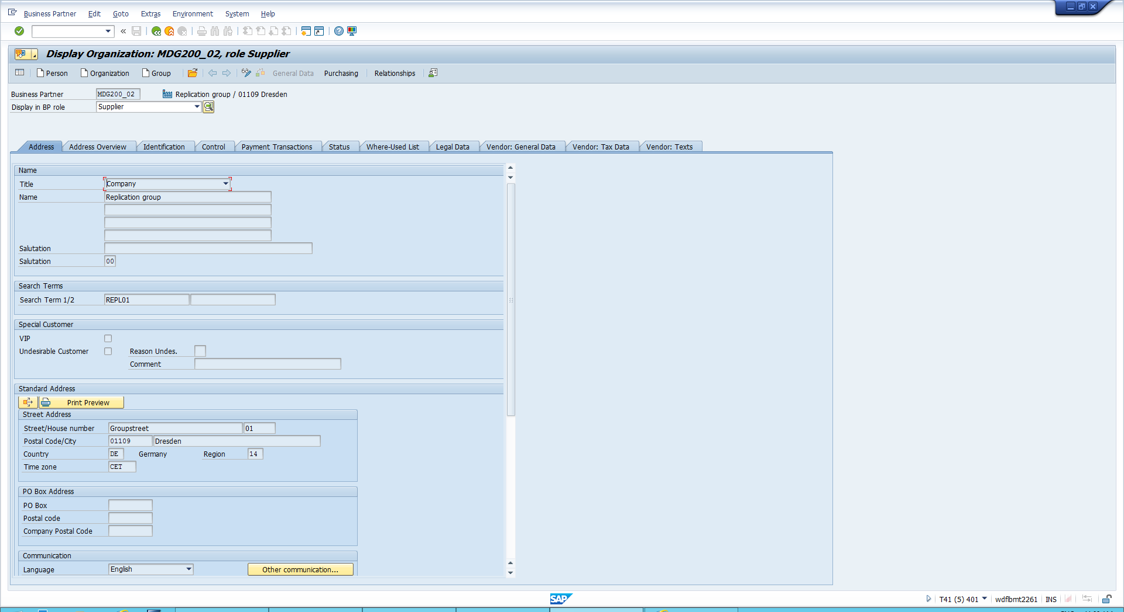

vi) Open purchasing view 🡪 Change purchasing organisation to 1010

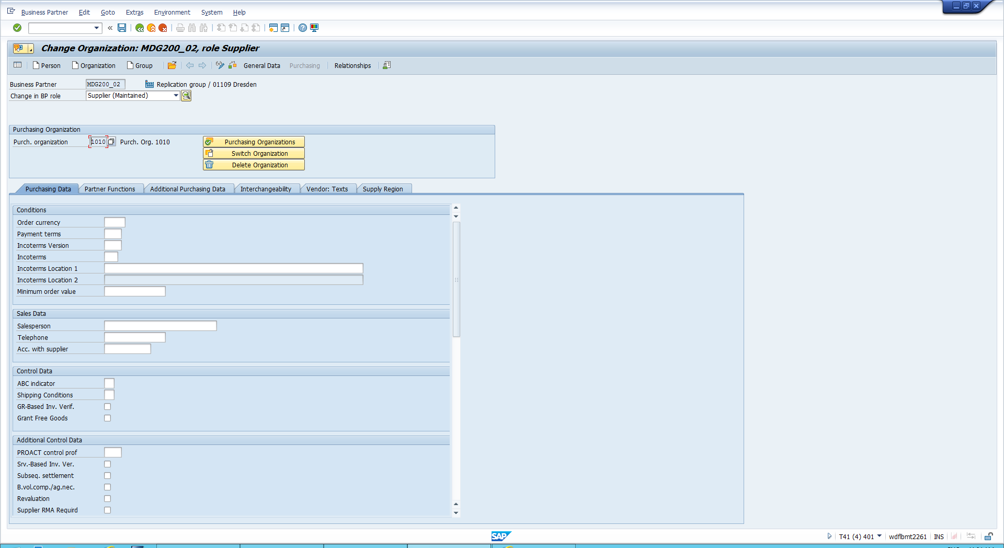

vii) Click on General data view beside Purchasing 🡪 Open Vendor General Data 🡪 You can now see the vendor number assigned in T41 system

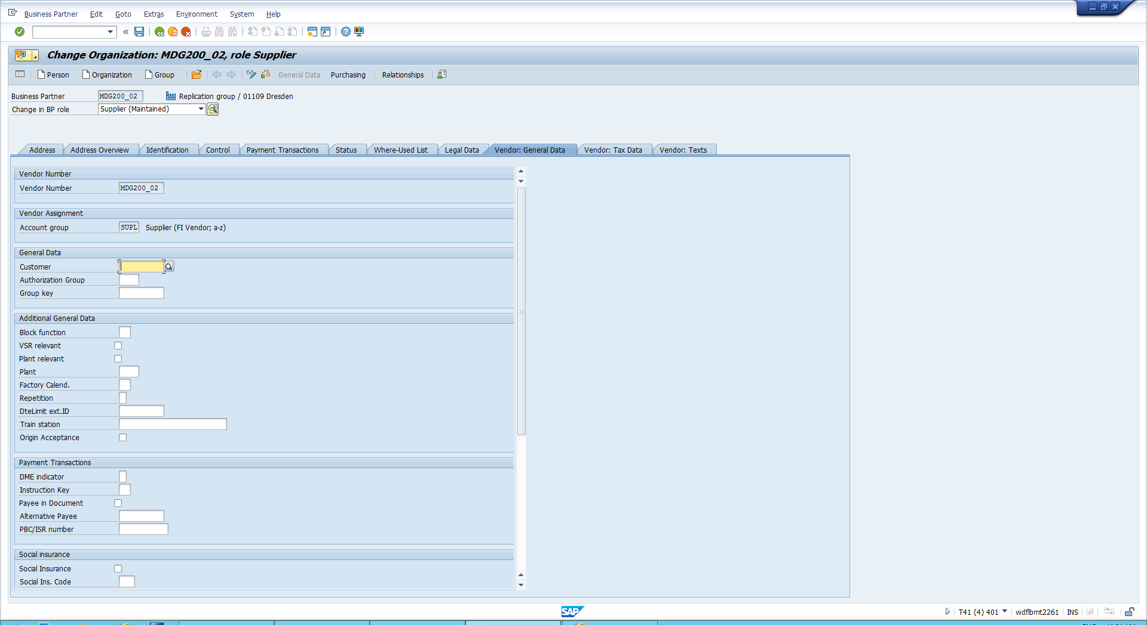

Checking the Key mapping

i) Open transaction SA38 🡪 Enter this program ‘CVI_MAPPING_BP_VEND’

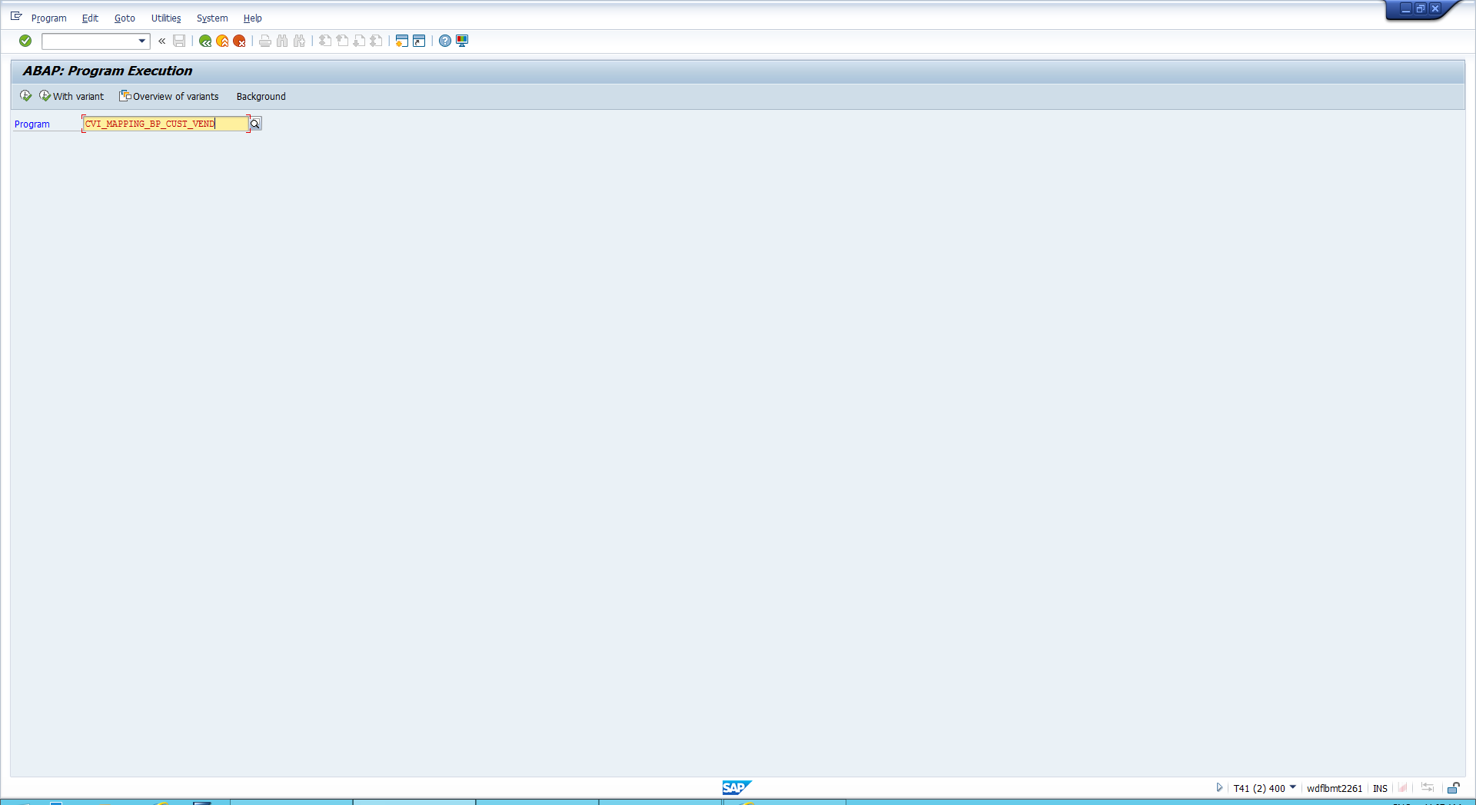

ii)Enter the following details

*Find : Vendor*

*Mapped to Business Partner*

*Number: Business partner id*

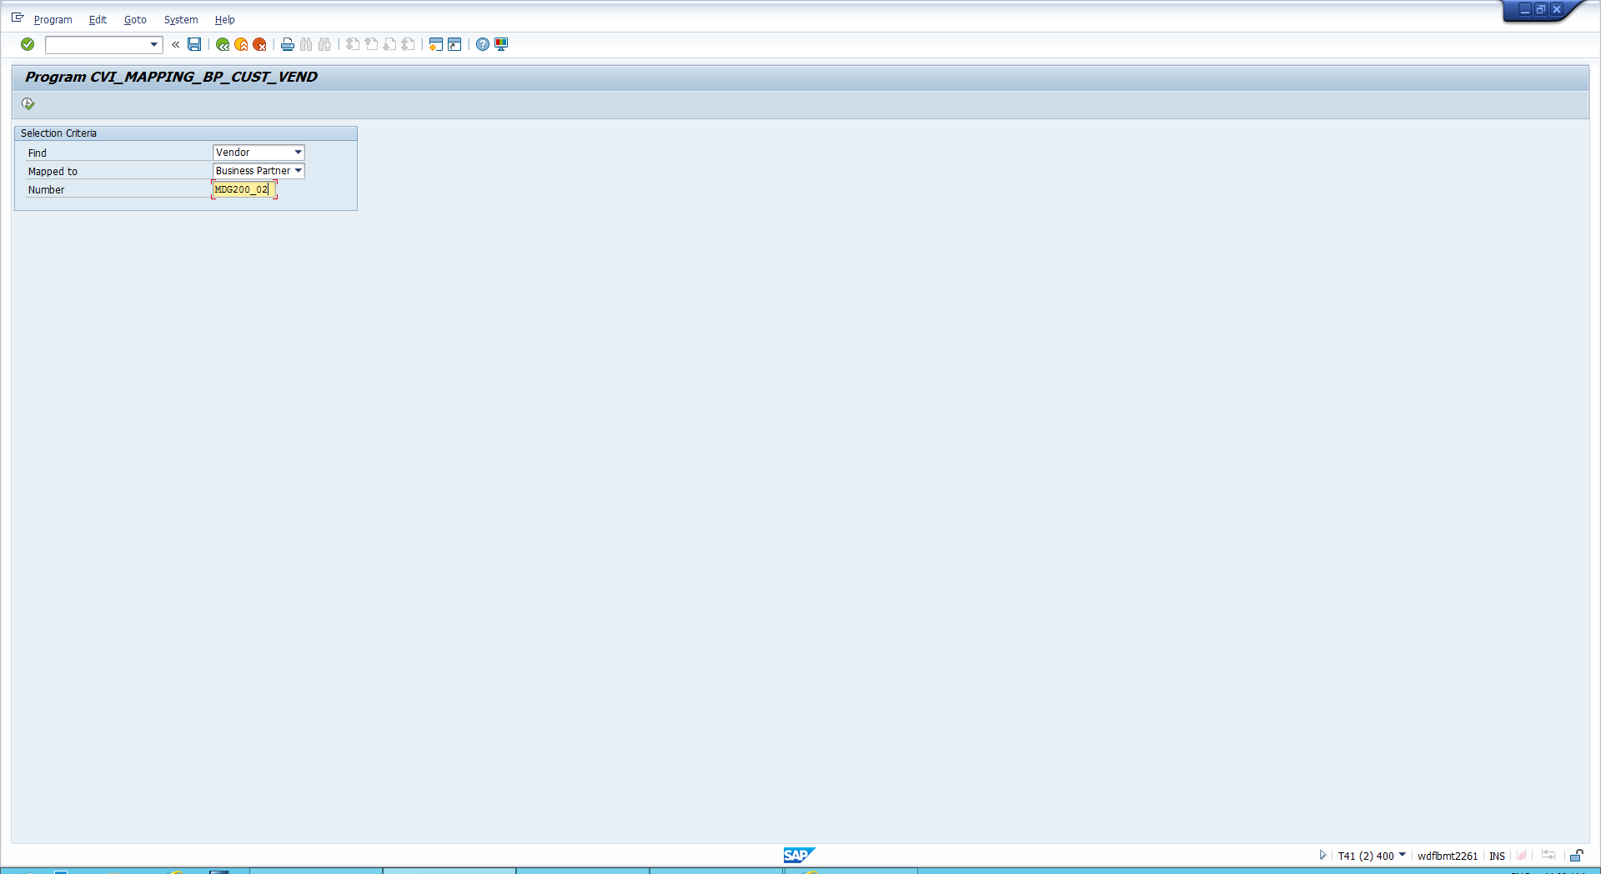

iii)See your Key mapping result

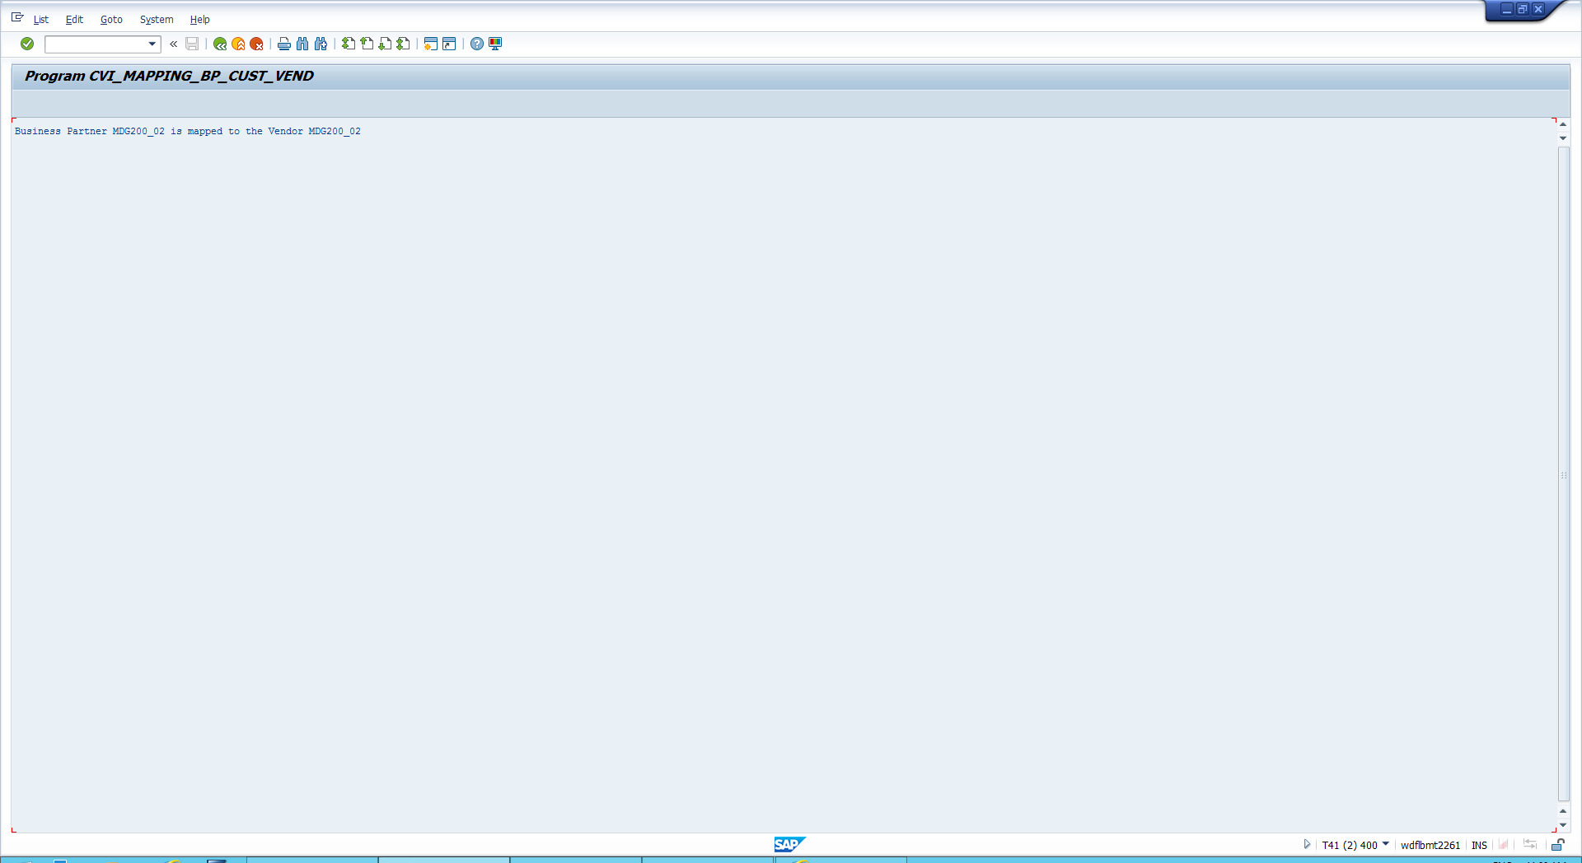

In the following steps you will navigate to transaction BP, search for business partner and check the supplier number